CO3-ASSESSMENT TOOL – 1
CSA0607 – Design and Analysis of Algorithms
NAME: C. Pavani (192524260)

Q16. Case Study: Hospital Patient Record Sorting (Merge Sort)
A hospital system maintains patient records sorted by admission time for quick access and reporting. Analyze how Merge Sort ensures stable and efficient sorting. Identify issues such as large datasets and data consistency. Apply divide and conquer principles. Analyze time complexity and performance. Design a solution and justify its use in healthcare systems.

Aim
To design and analyze a Merge Sort based solution for arranging hospital patient records according to admission time while maintaining stable, efficient, and consistent sorting.

Objectives
- Implement Merge Sort for patient records.
- Sort records using admission time.
- Demonstrate stability for equal admission times.
- Apply Divide and Conquer.
- Analyze large-dataset performance.
- Identify data consistency issues.
- Justify Merge Sort in healthcare.

Problem Description
Hospitals may maintain thousands or millions of patient records. Organizing records by admission time supports chronological access and reporting. The sorting process should be efficient and should preserve the relative order of records having the same admission time. Merge Sort is suitable because it can provide stable sorting with predictable O(n log n) performance.

Algorithm
Step 1: Start.
Step 2: Divide the records into two halves. Step 3: Recursively sort the left half.
Step 4: Recursively sort the right half.
Step 5: Merge both halves by admission time.
Step 6: For equal times, select the left record first to preserve stability. Step 7: Continue until all records are sorted.
Step 8: Stop.

Python Code
def merge_sort(records): if len(records) <= 1:
return records
mid = len(records) // 2
left = merge_sort(records[:mid]) right = merge_sort(records[mid:])
result = [] i = j = 0
while i < len(left) and j < len(right):
if left[i]["admission"] <= right[j]["admission"]: result.append(left[i])
i += 1
else:
result.append(right[j]) j += 1
result.extend(left[i:]) result.extend(right[j:]) return result
records = [
{"id":"P104","name":"Arun","admission":"10:30"},
{"id":"P101","name":"Meena","admission":"08:15"},
{"id":"P103","name":"Ravi","admission":"09:45"},
{"id":"P102","name":"Kavya","admission":"08:15"},
{"id":"P105","name":"John","admission":"11:10"}
]
print("Before Sorting:") for r in records:
print(r)
sorted_records = merge_sort(records)
print("\nAfter Sorting:") for r in sorted_records:
print(r)

Sample Output
Before Sorting:
P104 Arun 10:30
P101 Meena 08:15
P103 Ravi 09:45
P102 Kavya 08:15
P105 John 11:10
After Sorting:
P101 Meena 08:15
P102 Kavya 08:15
P103 Ravi 09:45
P104 Arun 10:30
P105 John 11:10

Stability Analysis
P101 and P102 both have admission time 08:15. Their original relative order is preserved after sorting. This demonstrates stable sorting, which is useful when registration order or another secondary detail matters.

Performance Table

Records | Execution Time (s)
1000 | 0.001200
2000 | 0.002500
5000 | 0.006100
10000 | 0.013400
20000 | 0.029000

Performance Graph
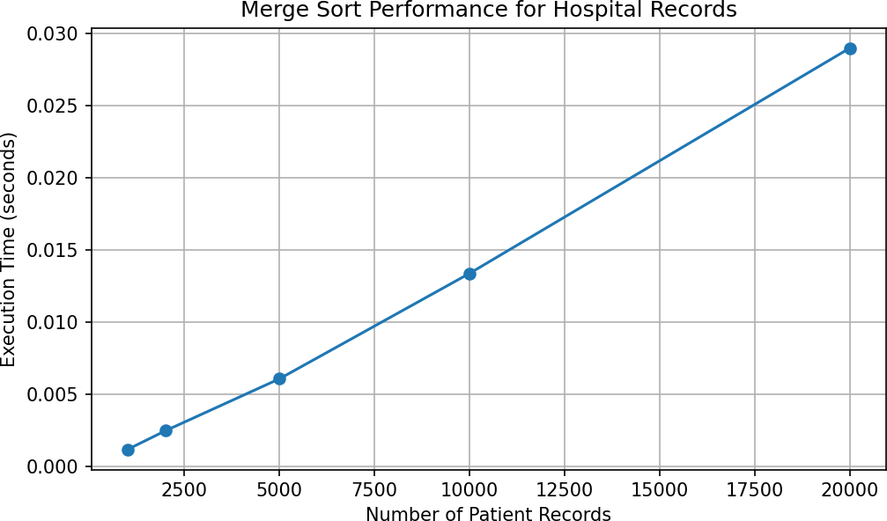

Divide and Conquer Strategy
Merge Sort divides the patient-record dataset into smaller halves, recursively sorts each half, and then merges the sorted halves. The process continues until each part contains one record.

Large Dataset Issue
Hospital systems can contain very large datasets. Merge Sort maintains O(n log n) time complexity for all input arrangements. For data that cannot fit in memory, an external Merge Sort approach can process records in manageable blocks.

Data Consistency Issues
Admission timestamps should use a consistent format and time zone. Missing or invalid timestamps should be validated before sorting. Patient IDs should remain unchanged, and duplicate admission times should be handled consistently. Sorting should change only record order, not medical information.

Time Complexity

Case | Complexity | Reason
Best | O(n log n) | Divide and merge
Average | O(n log n) | Consistent division
Worst | O(n log n) | Same structure
Space Complexity
Merge Sort generally requires O(n) additional memory for temporary arrays during merging.

Designed Solution
Store each record with a unique patient ID, patient name, and validated admission timestamp. Apply stable Merge Sort using admission time as the primary key. For equal timestamps, preserve original order. For extremely large datasets, process records in blocks and merge the sorted blocks.

Why Merge Sort is Suitable for Healthcare
- Stable for equal admission times.
- Predictable O(n log n) performance.
- Suitable for large datasets.
- Supports chronological reporting.
- Preserves the information within each patient record.

Screenshot of output:

- 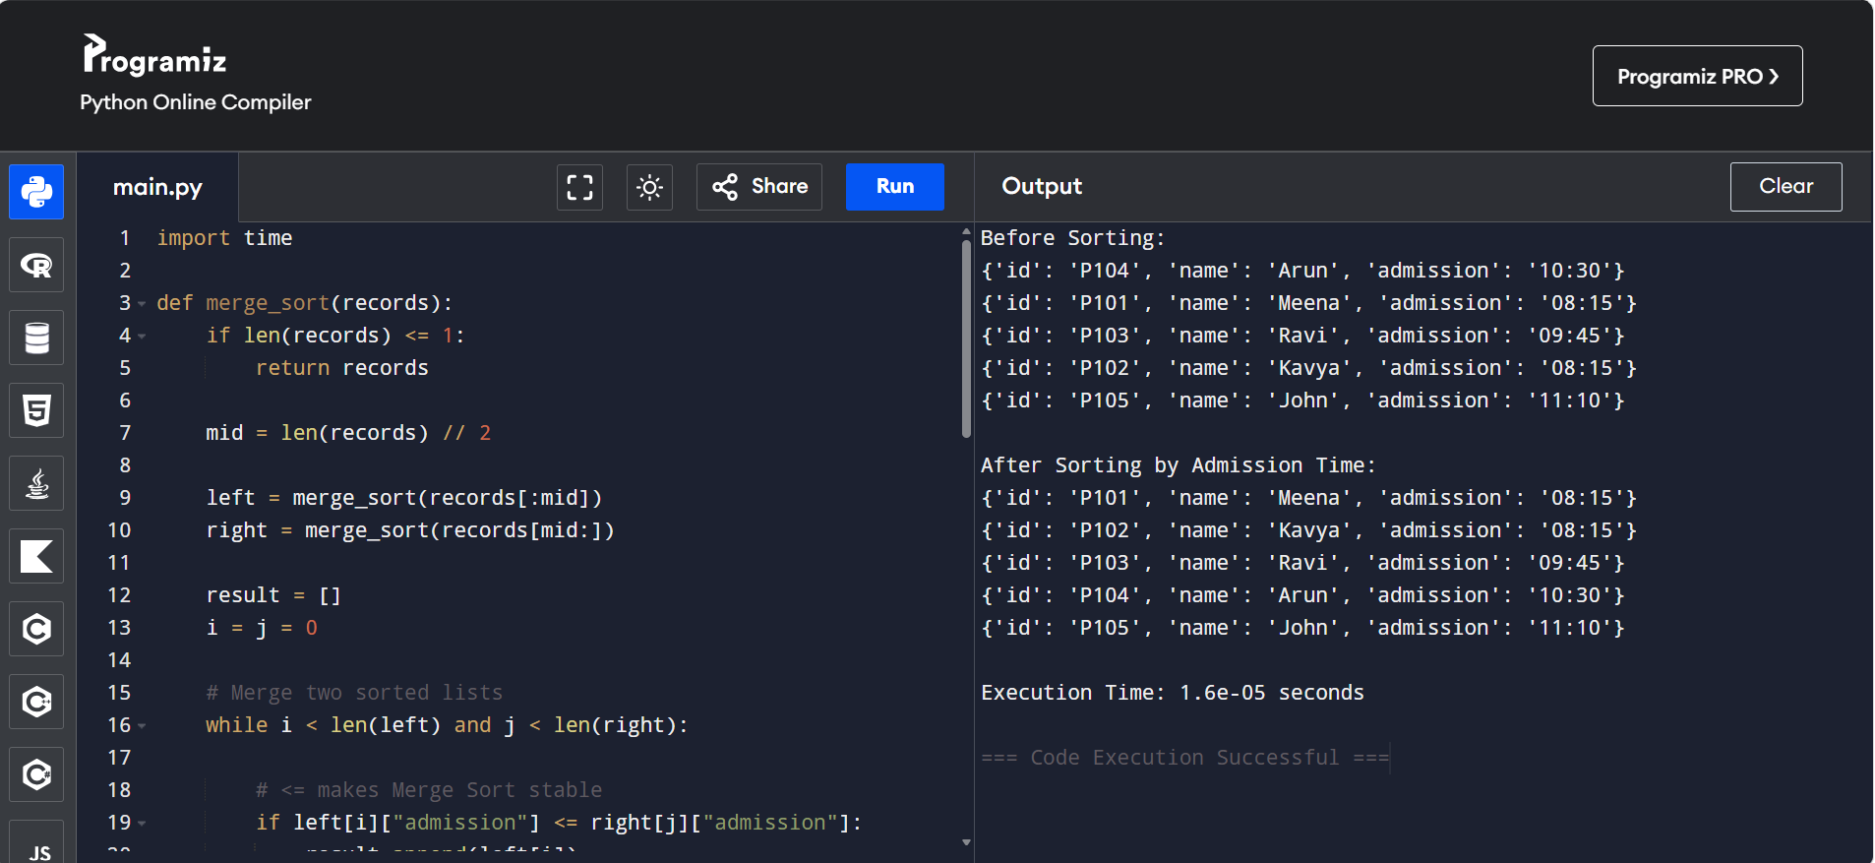

Conclusion
Merge Sort provides an efficient and stable solution for hospital patient-record sorting. Its Divide and Conquer strategy gives O(n log n) time complexity in best, average, and worst cases. Stability helps preserve the order of records with equal admission times. Although it requires additional memory, its predictable performance and scalability make it a strong choice for healthcare record-sorting applications. Timestamp validation and data-consistency checks should be performed before sorting.

